# Introduction to MobaXterm

MobaXterm is a comprehensive terminal application with many features that provides remote computing tools such as SSH, RDP, X11, SFTP, FTP, Telnet, Rlogin etc for programmers, webmasters, IT administrators, and other users.

**Setting up MobaXterm on your local computer**

To install MobaXterm, go to the [MobaXterm website](https://mobaxterm.mobatek.net/) and selected 'Download' at the top of the page

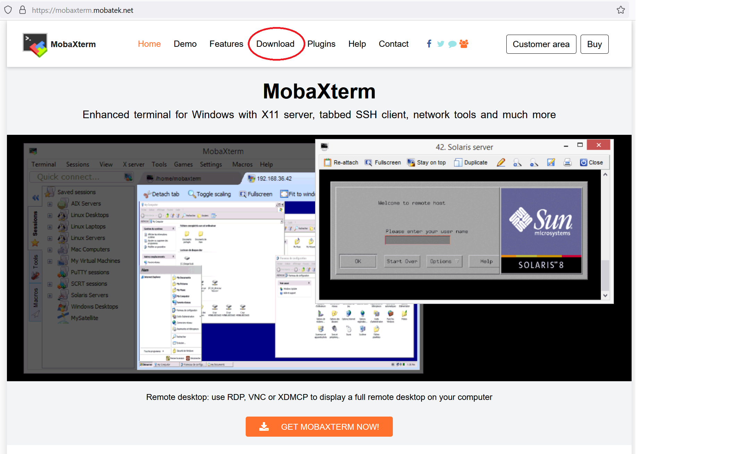

On the next page, choose "Download Now" under Home Edition

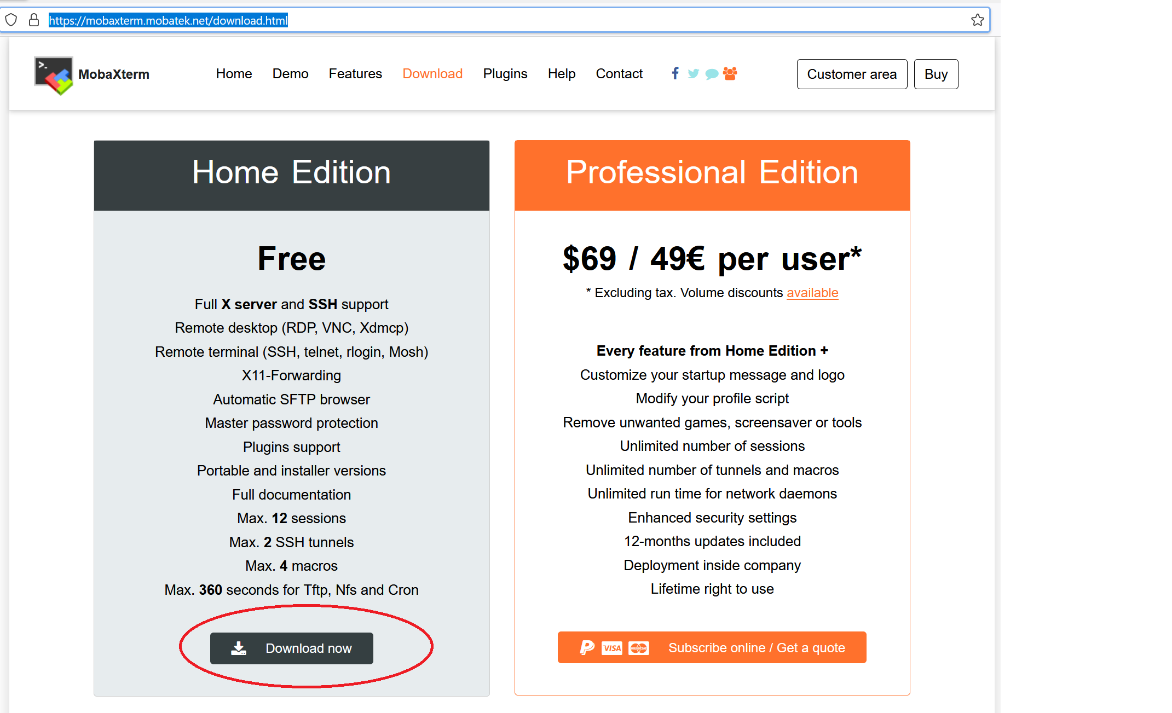

Finally, click the blue "Portable Edition" button or the green installer edition.

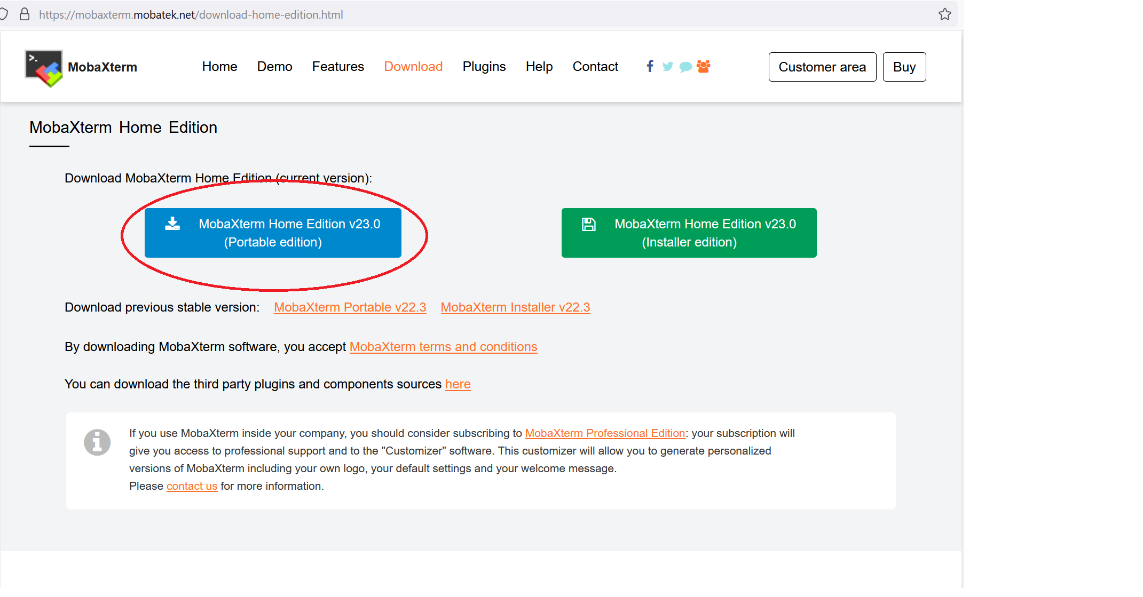

The Portable offers the convenience of unzip and run, no need for installation.

Go into the unzipped folder and click on the MobaXterm application to run the program

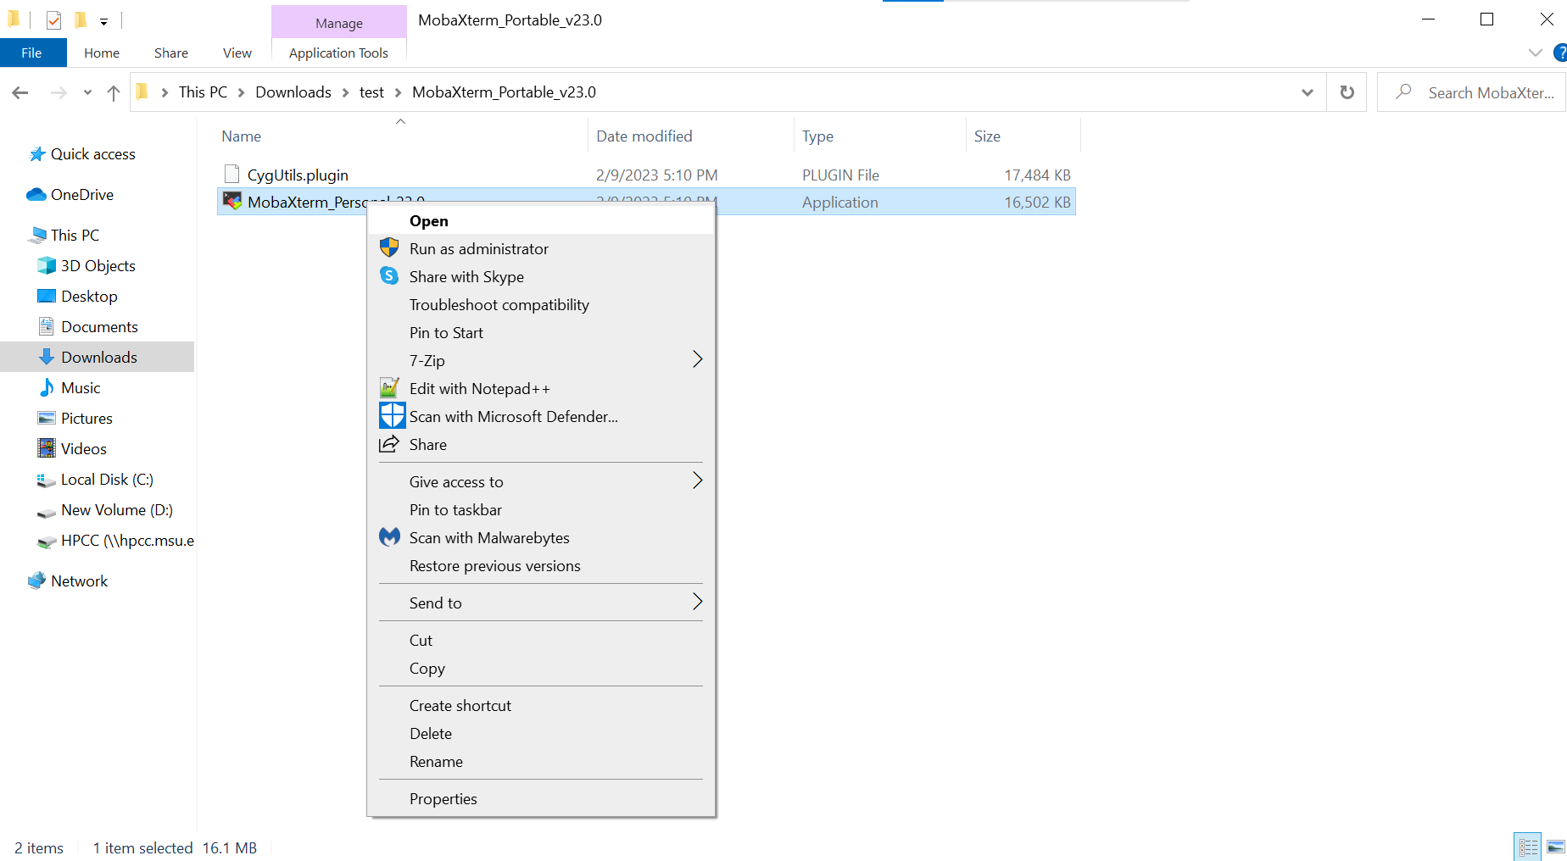

**Setting up and SSH connection session to FEDGEN HPC CLUSTER**

MobaXterm allows to define a 'SSH Session' to simplify the process of connecting to a remote server. First, start MobaXterm, then click on the "Session" button in the upper left.

Next, choose the "SSH" option from pop-up menu

In the following menu, fill in "allot.hpc.fedgen.net" as the remote host. Then check the "Specify username" box and fill in your Fedgen Username.

Now, if you click the yellow star on the left panel, you should see a line in the 'User sessions' column named something like "allot.hpc.fedgen.net (Fedgen UserID)

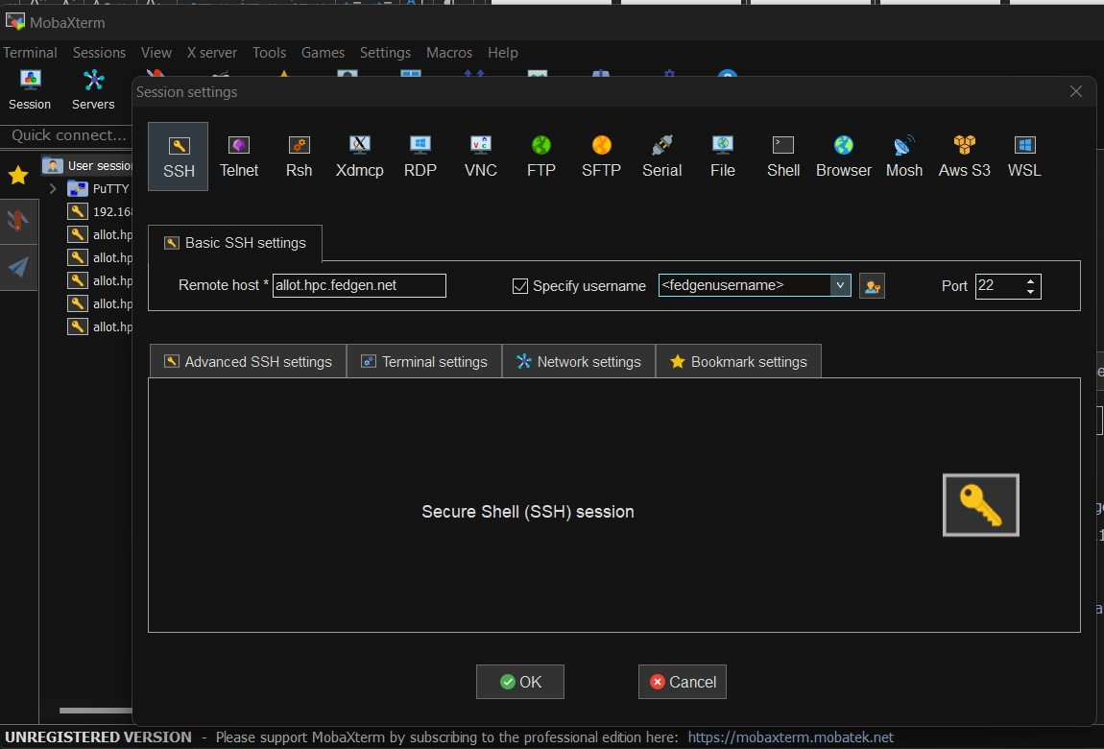

Click this and you will be prompted to enter the password for your username, after which you will be logged into Allot login node.

**Copying files to and from the cluster**

After you connect to the cluster successfully, you will see on the left sidebar on the *Sftp* tab a file browser on the cluster you are connected to.

You can simply drag and drop files from your computer to that panel and they will be copied to the cluster. The same is valid for retrieving files from the cluster to your computer.

If you right click on that panel, you will see different options to interact with the sftp browser (see the figure below). Remember always to press the Refresh current folder button **after** you copied something or a new file or folder is created on the cluster.

